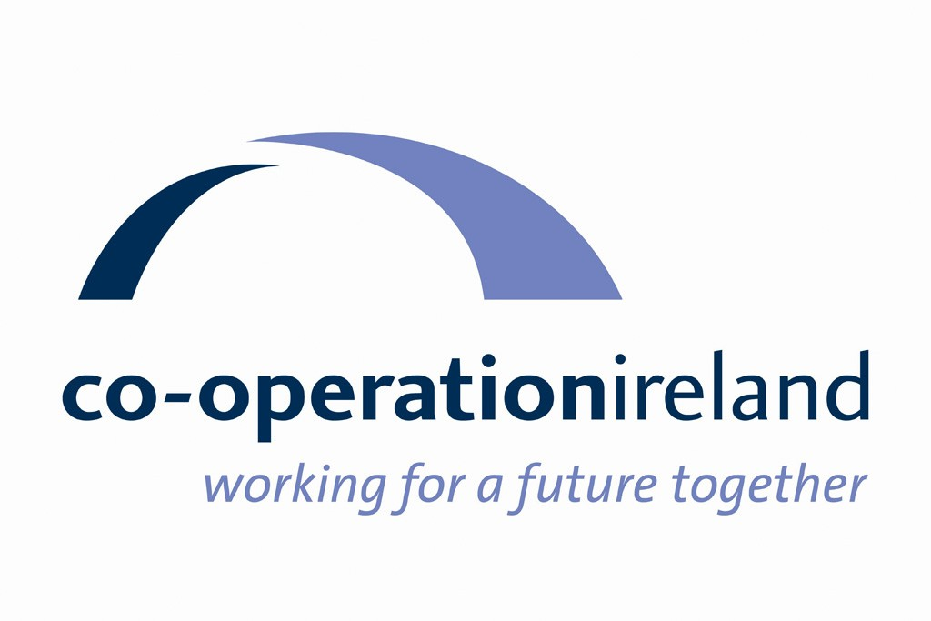

Co-operation Ireland

Strategic Plan

2025 - 2029

Who We Are

Co-operation Ireland is an all-island peace building charity. Established in 1979 as Co-operation North, we have for over 40 years worked to promote interaction, dialogue, and practical collaboration within Northern Ireland and between Northern Ireland and the Republic of Ireland. While our role has evolved in line with the changing priorities for peace on the island, at the core of our philosophy remains the belief that getting people to work together for mutual benefit, across religious, cultural, and political divisions, will promote greater understanding, respect and recognition of mutual interdependence.

Our Vision

Co-operation Ireland’s vision for the future of the island of Ireland is of:
An island at peace where people of all backgrounds live harmoniously and work together for a better future

Our Mission

Our mission is to advance peace and reconciliation by helping to build a shared and cohesive society and by strengthening relationships across these islands

We do this by working in partnership with others, including governments, to:
- Develop initiatives which address emerging challenges to peace
- Facilitate understanding, positive relationships and co-operation across these islands, building a sense of interdependence
- Create a supportive environment by building capacity, influencing policy, and developing collaboration at a strategic level
- Share our learning and experience of peace building and practical co-operation

Strategic Priorities 2025-29

Co-operation Ireland will work to deliver the following Strategic Priorities in the period 2025-29:

Strategic Priority 1

Promote dialogue, co-operation, respect, mutual understanding, and positive relationships across society throughout these islands and share our learning and experience

Strategic Priority 2

Assist post-conflict transition in marginalised communities and encourage and support integration of new communities by developing leadership and capacity for community renewal and active participation in a shared society

Strategic Priority 3

Develop and empower young and emerging leaders to make a positive contribution to the peaceful development of their communities and these islands as a whole

Strategic Priority 4

Ensure the organisation is resilient, agile, and effective, with a sustainable funding base and the capacity to deliver on our strategic priorities.

Implementation of this strategy will be taken forward through the preparation of annual operational plans which will set out detailed actions and outputs under each priority.

Annex A presents a set of Key Performance Indicators which will be used to monitor progress in delivery.

Annex A: Strategic Plan 2025-29 Key Performance Indicators

Strategic Priority 1 | Promote dialogue, co-operation, respect, mutual understanding, and positive relationships across society throughout these islands and share our learning and experience
Outcomes | Key Performance Indicators
Outcomes | ID/Title | Definition | Measurement | Target | Reporting Frequency | Responsible for reporting
Outcome 1.1  Positive relationships and collaboration are maintained and strengthened across these islands | KPI 1.1.1  Participation in relationship building and co-operation programmes | No. of participants in relationship building and co-operation programmes delivered by CI (directly or as lead partner) per year | Monthly project progress reports | 1500 participants in relationship building and co-operation programmes per year | Monthly | Paul Boylan
Outcome 1.2  Dialogue and deliberation at all levels of society promotes greater understanding of priorities and perspectives across these islands and contributes to a shared vision for the future | KPI 1.2.1  Opportunities created for dialogue | No. of dedicated opportunities created by CI (directly or as lead partner) for structured dialogue on good relations and co-operation across these islands, including facilitated forums, public and private events, and small group discussions | Monthly recording of opportunities created by CEO, SLT and relevant staff | 30 opportunities for dialogue created per year | Monthly | Ian Jeffers
Outcome 1.3  Government policy and public opinion are supportive of peacebuilding and co-operation across these islands | KPI 1.3.1  Contributions to policy and public debate | No. of contributions to public debate and influencing policy per year, including submissions to government consultations, policy papers, meetings with policy makers, conference addresses, and public speeches | Monthly recording of contributions by CEO, SLT, and relevant staff | 24 contributions to policy and public debate per year | Monthly | Ian Jeffers

Strategic Priority 2 | Assist post-conflict transition in marginalised communities and encourage and support integration of new communities by developing leadership and capacity for community renewal and active participation in a shared society
Outcomes | Key Performance Indicators
Outcomes | ID/Title | Definition | Measurement | Target | Reporting Frequency | Responsible for reporting
Outcome 2.1  New and marginalised communities will have greater capacity to take the lead in their own development and actively participate in a shared society | KPI 2.1.1  Participation in capacity-building for community renewal | No. of participants taking part in community renewal leadership and capacity building initiatives delivered by CI (directly or as lead partner) per year | Monthly project progress reports | 200 participants in leadership and capacity building initiatives per year | Monthly | Paul Boylan
 | KPI 2.1.2  Reach of capacity building initiatives for community renewal | No. and spread (community background, geography) of groups participating in community renewal leadership and capacity building initiatives delivered by CI (directly or as lead partner) per year | Monthly project progress reports/ Project monitoring | 25 groups participating in community renewal initiatives per year | Monthly | Paul Boylan

Strategic Priority 3 | Develop and empower young and emerging leaders to make a positive contribution to the peaceful development of their communities and these islands as a whole
Outcomes | Key Performance Indicators
Outcomes | ID/Title | Definition | Measurement | Target | Reporting Frequency | Responsible for reporting
Outcome 3.1  Participants in our youth empowerment programmes will have the capacity and confidence to contribute to peacebuilding and positive change in their communities and beyond | KPI 3.1.1  Participation in youth empowerment programmes | No. of participants taking part in youth empowerment programmes delivered by CI (directly or as lead partner) per year | Monthly project progress reports | 500 participants in youth empowerment programmes per year | Monthly | Paul Boylan
 | KPI 3.1.2  Completion of youth empowerment programmes | % of participants completing the youth empowerment programme in which they are registered per year | Project monitoring | 75% of participants complete the youth empowerment programme in which they are registered per year | Annually | Paul Boylan

Strategic Priority 4 | Ensure the organisation is resilient, agile, and effective, with a sustainable funding base and the capacity to deliver on our strategic priorities
Outcomes | Key Performance Indicators
Outcomes | ID/Title | Definition | Measurement | Target | Reporting Frequency | Responsible for reporting
Outcome 4.1  Co-operation Ireland is a financially stable organisation | KPI 4.1.1  Improved cash reserves | No. of months operating expenditure covered by cash reserves | Finance reporting | Cash reserves will cover 3 months operating expenditure from end of 2026 onwards | Quarterly | Sara McKerr
 | KPI 4.1.2  Programme surplus | % surplus achieved on programmes financed through fund raising | Finance reporting | Commercial initiatives/ programmes financed through fund raising will achieve a 20% surplus | Quarterly | Sara McKerr
Outcome 4.2  Co-operation Ireland offers a good working environment, encouraging the retention of committed and motivated staff | KPI 4.2.1  Staff engagement | % of employees scoring 9 -10 on Net Promoter scale less % of employees scoring 0-6 | Employee Net Promoter Score survey | Employee NPS > 30 | Biannually | Ian Jeffers

